Functional Requirements Document (FRD)
Project: Hezop PID Reader
Version: 1.0
Prepared for: Hezop Development & Stakeholder Teams

Table of Contents
- Introduction
1.1. Purpose
1.2. Scope
1.3. Definitions, Acronyms, and Abbreviations
1.4. References
1.5. Document Overview
- Overall Description
2.1. Product Perspective
2.2. Product Functions (High-Level)
2.3. User Classes and Characteristics
2.4. Operating Environment
2.5. Design and Implementation Constraints
2.6. Assumptions and Dependencies
- System Architecture
3.1. High-Level Architectural Overview
3.2. Component Diagram
3.3. Data Flow Diagram
- Functional Requirements
4.1. Module 1: File Management & Pre-Processing
4.2. Module 2: AI-Powered Symbol & Text Recognition
4.3. Module 3: Entity Relationship Mapping & Validation
4.4. Module 4: Data Structuring & Export
4.5. Module 5: User Interface & Interaction
4.6. Module 6: Administration & System Management
- Non-Functional Requirements
5.1. Performance Requirements
5.2. Security Requirements
5.3. Usability Requirements
5.4. Reliability & Availability
5.5. Scalability & Maintainability
- External Interface Requirements
6.1. User Interfaces
6.2. Hardware Interfaces
6.3. Software Interfaces
6.4. Communication Interfaces
- Appendices
Appendix A: PlantUML Diagrams - Source Code
Appendix B: Glossary of P&ID Symbols & Terms
Appendix C: Revision History

1. Introduction
1.1. Purpose
This Functional Requirements Document (FRD) defines the detailed capabilities, behaviors, and interfaces of the Hezop PID Reader system. It serves as the definitive guide for developers, testers, project managers, and stakeholders to understand what the system must do, providing a basis for design, implementation, and verification.
1.2. Scope
The Hezop PID Reader is an AI-powered software application designed to automatically interpret Process and Instrumentation Diagrams (P&IDs) in digital formats (PDF, raster images, vector files) and convert them into structured, queryable data. The scope includes:
- In-Scope: Uploading drawings, AI/ML-based recognition of symbols and text, extraction of equipment/instrument tags and properties, mapping of connectivity and process flow, structured data output (JSON, SQL), a web-based user interface, and integration APIs.
- Out-of-Scope: Creation or editing of original P&ID drawings, physical plant control, real-time sensor data ingestion, and advanced simulation within the tool itself.
1.3. Definitions, Acronyms, and Abbreviations
Term | Definition
P&ID | Piping and Instrumentation Diagram. A detailed diagram in the process industry showing the piping, equipment, instrumentation, and process flow.
Equipment | Major physical items in a process plant (e.g., P-101 Pump, T-202 Tank).
Instrument | Devices for measurement, indication, or control (e.g., PT-101 Pressure Transmitter, FV-201 Flow Control Valve).
Tag | A unique alphanumeric identifier for an equipment or instrument (e.g., P-101A).
Line Number | A unique identifier for a pipeline segment, specifying fluid, size, class, etc.
AI/ML | Artificial Intelligence / Machine Learning.
CMMS | Computerized Maintenance Management System.
ERP | Enterprise Resource Planning system.
EPC | Engineering, Procurement, and Construction firm.
JSON | JavaScript Object Notation, a lightweight data-interchange format.
API | Application Programming Interface.
1.4. References
- Project Charter: Hezop PID Reader.
- ISO 14617 & ISA S5.1: Standard P&ID Graphical Symbols.
- User Needs and Market Analysis Document.
1.5. Document Overview
This document is organized to first describe the system's context and high-level features, then detail its architecture, followed by an exhaustive list of functional requirements grouped by module. It concludes with non-functional requirements and interface specifications.

2. Overall Description
2.1. Product Perspective
The Hezop PID Reader is an independent, cloud-native SaaS application. It acts as a critical data transformation layer, ingesting unstructured drawing files and outputting structured intelligence. This output can feed into downstream systems like Digital Twin platforms, CMMS, ERP, and Asset Management systems.
2.2. Product Functions (High-Level Summary)
- Ingest multiple P&ID file formats.
- Pre-process images for clarity and consistency.
- Detect and Classify graphical symbols (equipment, instruments, valves) using computer vision.
- Optically Recognize all text (tags, line numbers, annotations).
- Associate detected text with the nearest symbol or line.
- Map Relationships (connectivity, upstream/downstream).
- Structure all extracted data into a logical hierarchy (Plant > Unit > System > Component).
- Allow Users to validate, correct, and enrich the AI output via a visual interface.
- Export the final structured dataset in standard formats.
- Manage users, projects, and drawing sets.
2.3. User Classes and Characteristics
User Class | Characteristics & Key Requirements
Process Engineer | Primary user. Needs fast data extraction for studies (HAZOP, SIL). Requires high accuracy and ability to verify/correct.
Digitalization Lead | Wants to batch-process entire plant libraries. Focus on data completeness, export formats, and integration.
Plant Manager | Needs high-level summaries, dashboard views of plant assets from drawings.
System Administrator | Manages user accounts, system configuration, and monitors processing health.
2.4. Operating Environment
- Software: Modern web browsers (Chrome, Edge, Firefox). Backend: Cloud-based (e.g., AWS, Azure) with containerized microservices (Docker/Kubernetes).
- Hardware: Server-side requires GPUs for AI inference. Client-side requires standard PC/laptop.
2.5. Design and Implementation Constraints
- Must support ISO/ISA standard P&ID symbols as a baseline.
- Must comply with GDPR/CCPA if handling user-uploaded proprietary data.
- Initial release will focus on English-language text recognition.
- AI model must be retrainable to adapt to client-specific drawing standards.
2.6. Assumptions and Dependencies
- Assumption: Input drawings are legible digitized copies, not poor-quality scans.
- Dependency: Use of third-party OCR and ML frameworks (e.g., Tesseract, PyTorch/TensorFlow).
- Dependency: Availability of a labeled dataset of P&IDs for initial model training.

3. System Architecture
3.1. High-Level Architectural Overview
The system follows a layered microservices architecture:
- Presentation Layer: React-based Web Application.
- Application Layer: API Gateway and core business logic services (File Service, AI Engine, Data Mapping Service).
- Data Layer: Database (PostgreSQL for structured data, blob storage for drawings).
- AI/ML Layer: Dedicated services for CV, NLP, and model serving.
3.2. Component Diagram
See Appendix A.1 for PlantUML source and diagram.
3.3. Data Flow Diagram
See Appendix A.2 for PlantUML source and diagram.

4. Functional Requirements
4.1. Module 1: File Management & Pre-Processing
Req. ID | Requirement Description | Priority
FR-1.1 | The system shall allow users to upload P&ID files via a drag-and-drop interface or file browser. | Must Have
FR-1.2 | The system shall support the following file formats: PDF, PNG, JPEG, TIFF, DWG/DXF (via conversion). | Must Have
FR-1.3 | The system shall validate file size (max 100 MB per file) and type upon upload. | Must Have
FR-1.4 | The system shall automatically convert PDFs and CAD files to high-resolution raster images (e.g., 300 DPI PNG) for processing. | Must Have
FR-1.5 | The system shall perform pre-processing on images: deskewing, noise reduction, and contrast enhancement. | Should Have
FR-1.6 | The system shall organize uploaded drawings into user-defined Projects and Batches. | Must Have
4.2. Module 2: AI-Powered Symbol & Text Recognition
Req. ID | Requirement Description | Priority
FR-2.1 | The AI engine shall detect and locate all graphical symbols present in a pre-processed P&ID image. | Must Have
FR-2.2 | The system shall classify detected symbols into a predefined library (e.g., Pump, Tank, Valve, Sensor, Heat Exchanger). | Must Have
FR-2.3 | The system shall perform Optical Character Recognition (OCR) to extract all text blocks from the image. | Must Have
FR-2.4 | The system shall interpret common P&ID tag numbering patterns (e.g., P-101, T-202A, XV-3001). | Must Have
FR-2.5 | The system shall associate extracted text blocks (tags, annotations) with their nearest detected symbol or pipeline with 95%+ accuracy. | Must Have
FR-2.6 | The system shall extract line numbers and specifications (e.g., 4"-P-3010-6A1-H) from near pipeline segments. | Must Have
4.3. Module 3: Entity Relationship Mapping & Validation
Req. ID | Requirement Description | Priority
FR-3.1 | The system shall identify connection points between symbols (equipment, instruments) and pipelines. | Must Have
FR-3.2 | The system shall build a node-and-edge graph representing the process flow and connectivity. | Must Have
FR-3.3 | The system shall infer parent-child relationships (e.g., a Pump P-101 is part of System SYS-100). | Should Have
FR-3.4 | The system shall provide a visual interface where users can see the AI's interpretation overlaid on the original drawing for validation. | Must Have
FR-3.5 | Users shall be able to correct misclassified symbols, reassign tags, and add missing connections via the visual interface. | Must Have
FR-3.6 | The system shall learn from user corrections to improve future recognition for that project (active learning). | Could Have
4.4. Module 4: Data Structuring & Export
Req. ID | Requirement Description | Priority
FR-4.1 | The system shall compile all validated data into a structured hierarchical data model (Plant > Unit > System > Component). | Must Have
FR-4.2 | For each Equipment item, the system shall store: Tag, Type, Description (if found), and connected Lines/Instruments. | Must Have
FR-4.3 | For each Instrument, the system shall store: Tag, Type, Function (e.g., Indicating, Controlling), and associated Equipment. | Must Have
FR-4.4 | The system shall generate and export a comprehensive JSON schema representing the entire processed drawing. | Must Have
FR-4.5 | The system shall allow export of structured data to a SQL database schema (via script or direct connection). | Must Have
FR-4.6 | The system shall support batch export of all drawings within a Project. | Should Have

5. Non-Functional Requirements
5.1. Performance Requirements
Req. ID | Requirement Description | Metric
NFR-1.1 | The system shall process a standard A1-size P&ID (average complexity) in less than 2 minutes. | < 120 sec
NFR-1.2 | The web UI shall respond to any user action (click, drag) in less than 1 second. | < 1 sec
NFR-1.3 | The system shall support concurrent processing of at least 10 drawings per user. | 10 threads

6. External Interface Requirements
6.1. User Interfaces
- UI-1: Dashboard showing Project and Processing Status.
- UI-2: Interactive Drawing Canvas for validation (as per FR-3.4).
- UI-3: Data Table/Grid view of extracted entities with filtering.
6.4. Communication Interfaces
- API-1: RESTful API for programmatic file upload and data retrieval.
- API-2: WebSocket connection for real-time progress updates during long processing jobs.

7. Appendices
Appendix A: PlantUML Diagrams - Source Code
A.1 Component Diagram Source:
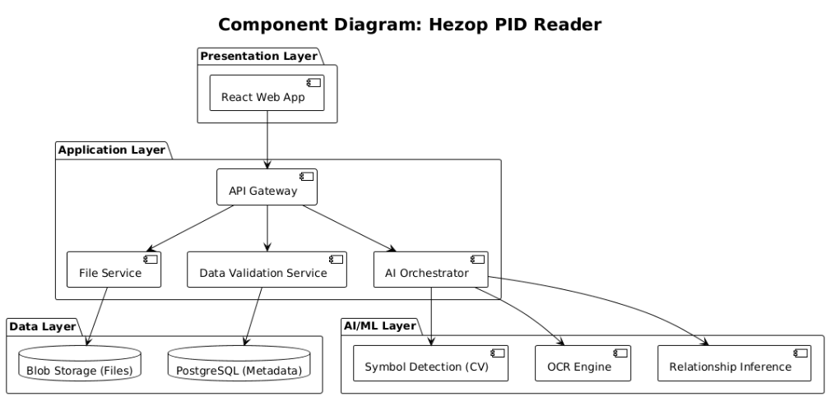
A.2 Data Flow Diagram (Level 1) Source:
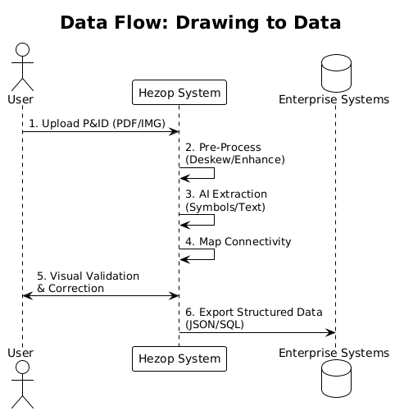
A.3 Use Case Diagram Source:
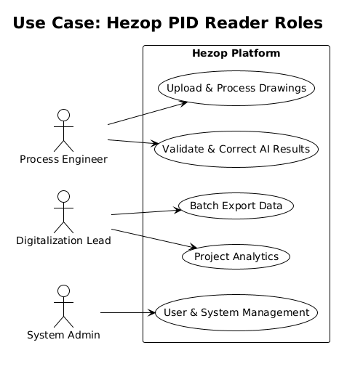
Appendix B: Glossary of P&ID Symbols & Terms
Appendix C: Revision History
Version | Date | Author | Description of Change
1.0 Draft | 2025-10-26 | [Your Name] | Initial creation of FRD.

